Graduation Essay
Dalton course

An Analysis of the Different Progressive Education Methods Contained within the School structure of the de La Tour School Seiersberg

Ralf Bradley BA and
Mag. Gregor Kolb

Submitted to Mag. Iris Enthaler BA

In association with the Pädagogische Hochschule Oberösterreich

Period of Study: 2018 / 2019
Seiersberg, April 2019
- Abstract

This paper will attempt to analyse the influences and elements of three progressive education philosophies contained and practised within the de La Tour School Seiersberg.

The de La Tour school Seiersberg is a newly formed school, founded in 2017 and has both a lower secondary and upper secondary part. It is a chartered school and therefore has more flexibility in the teaching and educational methods it practices when compared to mainstream schools in Austria.

This analysis contained within this work shall start with a general description of progressive education: what the term itself means, what the typical characteristics of progressive education philosophies are and the similarities between them.

Next, the paper shall compare three of the main progressive education theories, namely, the Dalton Plan, Montessori and Jena Plan. It will examine the general philosophy behind each as well as the features, similarities and differences. The purpose of this analysis is to be able to identify which features of each are employed at the de La Tour School Seiersberg.

This will be followed by a detailed explanation of the school rhythm at the de La Tour School Seiersberg. This will include a description of the different elements of the school day and, following on from this, an explanation of the structure of the school year. This paper will also attempt to explain the reasoning being the structures and methods used at the school.

Finally, the paper will draw a conclusion and explain its findings as to which progressive education philosophies are put into practice at the de La Tour School Seiersberg.

2. Contents

- Abstract.............................................................................................................. 2
- Contents..............................................................................................................3
- How can a school engage in learning?............................................................6
- Features of Progressive Education……………………………………………….7
  - The term of Progressive Education……………………………………………..7
  - Typical features of Progressive Education…………………………………….7
  - Similarities of Progressive Education……………………………………...……8
- Progressive Education in comparison.............................................................9
  - Dalton Plan Education Theory ......................................................................9
    - Freedom (through independent learning and planning and individual responsibility) ………………………………………………………………..10
      - Responsibility………………………………………………………11
    - Cooperation (amongst and between children, teachers and parents).12
    - Time management (through planning and independently working to achieve goals) ………………………………………………..……….……..13
  - Montessori Education Theory.......................................................................14
    - Principles of Montessori Pedagogy ……………………………….…….15
      - Independent work………………………………………………….15
      - The Montessori Teacher…………………………………………..16
      - Prepared environment………………………………………..……17
  - Jena Plan Education Theory..........................................................................18
    - Concept of the Jena-Plan-School……………………………………..….19
    - Foundations of Jenaplan……………………………………………….….20
      - Discussion…………………………………………………………..20
      - Play……………………………………………………………….….20
      - Work…………………………………………………………………21
      - Celebration…………………………………………………….……21
    - Group configuration…………………………………………………..……21
- School rhythm ...................................................................................................22
  - Start of the school day...................................................................................22
    - A comparison of school start times in Europe......................................22
    - Start of the school day: When is the best time to start for children´s learning and development?.....................................................................23
  - Montessori education.....................................................................................24
    - Sensitive phases…………………………………………........................24
    - Prepared environment……………………………………………............25
    - Role of the teacher…………………………………………………….…..25
    - Lessons according to Montessori……………………………………...…25
      - Open work……………………………………………………..……26
      - Interdisciplinary lessons………………………………….…..……26
  - Jenaplan education........................................................................................26
    - Recurring weekly planning…………………………………………..……26
    - Mixed aged tutor groups…………………………………………………..27
    - Avoidance of performance culture……………………………………….27
    - Parent-school community………………………………………..……….27
  - de La Tour School Seiersberg......................................................................28
    - Early morning care (Morgencafé)........................................................29
    - Start of the school day (Assembly) .....................................................30
      - How does it work at the de la Tour School Seiersberg?...........30
    - Open work phase (Dalton phase) .......................................................31
      - How open learning theory is put into practice at the de La Tour School Seiersberg………………………………………………….…..32
      - Learn plans (Assignments)
    - Recovery phase...................................................................................35
      - How the recovery phase is employed at the de la Tour School Seiersberg……………………………………………………………….35
    - Instruction/input phase (Special call) ..................................................37
    - Secondary subject phase (Subject conference) ..................................37
- Structure of the academic year.........................................................................38
  - Structure of the academic year at the de La Tour School Seiersberg………39
- Summary and comparisons..............................................................................40
  - Perception of the child...................................................................................41
  - Group configuration.......................................................................................43
  - Classroom.....................................................................................................43
  - Syllabus.........................................................................................................44
  - Teaching approach........................................................................................45
  - Learning content and methods......................................................................46
  - Seating arrangement.....................................................................................46
  - Teacher’s role................................................................................................47
  - School type....................................................................................................48
- Conclusion..........................................................................................................48
- Bibliography......................................................................................................50
  - Literature..............................................................................................50
  - Image reference...................................................................................51

3. How can a school engage in learning?

Paradoxically, a school must first unlearn what it has learned. To be precise, it must unlearn its old approach to learning. As such it should reflect on progressive educational philosophies and apply these bodies of thought according to the needs of its pupils. Such reflection can help the school orientate itself in times of decision making. School often hinder the learning process themselves as a result of an overdose of information and a tendency to work within systemic structures. It often appears easier to conform to the cultural norms as if such norms have a solution for every problem and adherence to them maintains control. People can be afraid to admit their own confusion.

When one is unable to solve a problem because it appears to complex, it generates frustration and fear. One tries to tackle this fear through an increased accumulation of knowledge. People have not learned to openly engage with problems. The universal approach is to save face and to protect oneself from perceived criticism. One does not admit to learning from mistakes, as in society mistakes are not permitted.

In order to achieve a lasting change in societal and personal attitudes, one requires the opportunity to practice and to make mistakes. Every mistake or failure presents a unique opportunity to learn and develop. In order to engage in such a process, people must feel safe. A school can provide an environment that encourages active participation in such processes through:

- Giving opportunities to practice and train
- Supporting and encouraging pupils to overcome the fear and the shame that is associated with making a mistake
- Coaching and rewarding pupils children’s endeavours in the right direction
- Rules, norms and conventions which allow accept failure and promote innovative thinking and experimentation
- A community in which it is possible to share fears which takes responsibility as a collective for the school
4. Features of progressive education

4.1. The term “Progressive Education”

The term ‘progressive education’ is not an easy one to define. The reason for this is due to the fact that it refers to many aspects and different educational approaches and concepts. Generally, the term encompasses all the ideas which attempt to change and reform current mainstream schools, teaching methods and education in general. All of the ideas which are group together under the term ‘progressive education’ have a common direction and goal, namely: to replace authoritarian education methods with liberal, democratic and less performance-focused methods.

4.2. Typical characteristics of progressive education

- Grades and pressure to achieve are typically avoided
- The individual and personal development are at the heart of every educational endeavour
- Lessons, education and general upbringing have the goal of encouraging independence through self-development processes
- The role of the teacher or educator differs from that of mainstream approaches: the teacher takes on the role of coach or development companion rather than an authoritative figure
- With regard to Methodology and didactics, progressive teachers experiment with new creative lesson designs with the intention of promoting more effective, playful, individual and intrinsically motivated learning
- Lessons tend to be more open, democratic and participatory Social-emotional and creative are encouraged along with practical real-life experiences, as opposed to just academic achievement
- Research results from developmental psychologists and medical experts are taken into consideration and appropriate methodologies are put into practice to support children as best as possible according to their age

4.3. Similarities of progressive education

Progressive teachers promote equality of opportunity and individual support for all children, regardless of their background. They aim to remove psychological pressure and monotony from education. The intention is to let the child’s own intrinsic desire to learn blossom. Concepts such as appreciation, responsibility for one’s own learning, diversity of methods, social competencies and practical learning are of utmost importance. Despite differing approaches, progressive education theories have much in common:

- Successful and long-lasting learning requires freedom
- A school is not just a place where things are learned – it is a social community
- A child is not treated as a young adult. Conversely, the age-specific and developmental needs and interests are recognised
- Education requires voluntary action from the learner
- Learning must take play in a within a notion of responsibility for oneself
- Educational content should have a recognisable link to everyday life
- School as well as the family home form part of a holistic personal development pathway

5. Progressive education in comparison

This section introduces the three progressive education philosophies which form the basis of the comparison.

5.1. Dalton Plan education theory

Dalton education theory was founded at the beginning of the 20th century by Helen Parkhurst. This method of education came from Parkhurst’s experience as a teacher of mixed aged and mixed ability classes as well as her training under the renowned educationalist Maria Montessori. Parkhurst and Montessori had a close professional relationship and continued to work closely together even after Parkhurst had completed her training. As a result, Dalton theory shares many ideas and principles with Montessori education theory.

“The fundamental principle consists of employing (traditional) teaching strategies in an environment of acquisitive didactics.”
Popp, Susanne, Der Daltonplan. in Theorie und Praxis.

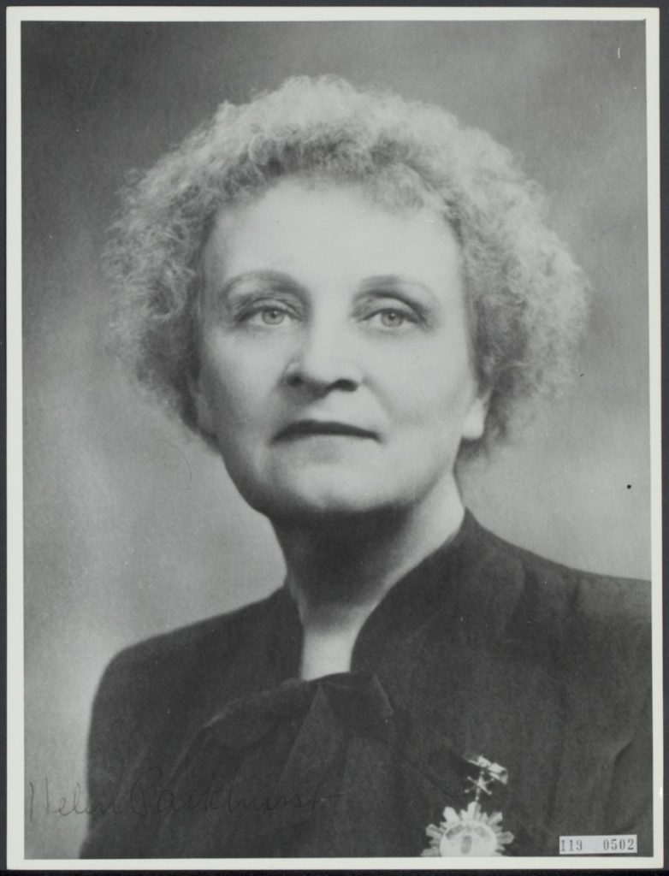
Picture Exhibit 1 Helen Parkhurst
One of the underlying concepts which both theories have in common is the belief that children have an inherent desire to learn. There is, therefore, according to Parkhurst, no need to stipulate when pupils should learn a particular topic. Instead, pupils should produce weekly and yearly learning plans under the guidance of their teachers, which they work on independently as far as possible.

The fundamental guiding principles of the Dalton Plan philosophy are:

- Cooperation
- Time Management
- Freedom

5.1.1. Freedom (through independent learning and planning and individual responsibility)

The Dalton Plan theory defines freedom as the freedom to decide with taking responsibility for one’s decisions. The fact that Parkhurst placed freedom at the heart of her educational concept is seen as reaction to the so-called ‘obligation school‘. According to Parkhurst, it is not the role of the teacher to always tell their pupils what they must do. The teacher’s purpose should be to help his/her pupil develop themselves.
Maria Montessori, Erziehungskonzept zur Selbstbestimmung
How should the freedom element of the Dalton Plan be put into practice in the classroom?
The pupil’s freedom of choice should enable them to become independent. As soon as a child is given a remit, it should be able to decide:
• with which task they may begin
• whether they will work individually or with a partner or with a group
• where they want to work on each task
• which of the available materials they will use and how
• how much time they would like to set aside for each task
• when they must begin working in order to finish in time
• which teacher to work with

The freedom of the teacher are, on the other hand, restricted. The teacher’s choices are more orientated around obligations:
• How many groups and of which level should the take for their learning group?
• What materials should they make available to their students?
• How many hours of their teaching time should they allocate to independent work?
• How many hours should they take for input?
• Should they mix the pupils in a homogenous or heterogeneous way?
• How should they design the remit?
• How should they correct the tasks?
• What daily colours should be used?

5.1.1.1. Responsibility

The Dalton plan aims to shift the focus of school from teaching and on to learning. In most mainstream schools the teacher preoccupies him/herself with making sure the children learn. A notable difference in the Dalton Plan approach is that the children are themselves responsible for making sure that they learn and progress. It is crucial that the pupils understand it as such. This relies on how the remit is presented and structured and it must contain the elements of freedom of choice and assignments. By giving the pupils responsibility for their own learning in the school, one empowers them to be self-confident and to take the initiative for themselves.

“Through giving pupils tasks in the form of remits (assignments) and with the clarity of knowing he/she is responsible for fulfilling it, the remit, as well as the pupil, are given a sense of ‘worth’. This giving of trust precipitates a growing confidence in their own abilities.”
Helen Parkhurst, Der Daltonunterricht und seine Stelle innerhalb reformpädagogischer Auffassungen.

This quote from Helen Parkhurst eludes to the importance she placed on the immense sensitivity a teacher must possess when it comes to trusting their pupils and trusting in their abilities. According to Helen Parkhurst, this giving of trust increases the sense of responsibility of children for dormant intelligence and the ability to assess themselves and their abilities, thereby strengthening their character.
Janssen, C. J., Der Daltonunterricht und seine Stelle innerhalb reformpädagogischer Auffassungen

5.1.2. Cooperation (amongst and between children, teachers and parents)

As mentioned above, cooperation is a cornerstone the Dalton Plan philosophy. In this context cooperation focus less so on the social ways in which children work, but rather on the abolition of socially-restrictive structures within a school. According to Parkhurst’s thinking, forms of social interaction and working, including inter-age and inter-class interactions, occur spontaneously and naturally once the prohibiting factor of frontal teaching has been removed.
Popp, Susanne, Der Daltonplan in Theorie und Praxis

Dalton Plan methodology seeks to turn the school into one holistic social unit from which a cooperative community arises. It is the task of the teachers to create this social unit. Teachers should continuously discuss the appropriate methods, daily colours, codes of conduct and many other intricate details in order to lead the school according to the Dalton Plan principles for the benefit of the pupils.

5.1.3. Time management (through planning and independently working to achieve goals)

The third major element of the Dalton Plan philosophy underpins the goal which the philosophy strives to instil in children: independence. The combination of the challenge of working on assignments to fulfil goals as well as the requirement of considered planning in order to meet the challenge aim to foster the independence of the child. Despite the goals of the assignment being prescribed, the child has the freedom to choose their methods, be it through working individually or seeking partners to cooperate with through active dialogue in order to find solutions to the problems and challenges which they encounter along the way.
Janssen, C. J., Der Daltonunterricht und seine Stelle innerhalb reformpädagogischer Auffassungen.

This element of planning from the beginning, following the plan and adhering to the allotted time attempts to engage the children in complex, but essential thought processes such as evaluating various situations, assessing one’s own abilities, seeking strategies and ideas. Through reinforcing these ideas, Helen Parkhurst hoped to foster the confidence that children and adults need to become independent.

The way assignments are designed around time management can vary greatly between Dalton Plan schools. However, the overarching goal is the same.

“Dalton is not a methodology, not a system, it is a way of life”
Helen Parkhurst

5.2. Montessori education theory
Maria Montessori, the founder of Montessori education theory, conceived her educational concept at the beginning of the 20th century and it has been applied in Montessori schools since 1907. The fundamental rationale behind this theory, similar to Dalton, is that children have a natural desire to learn. Children should not be told when and what should be learned, but rather supported to make such decisions themselves. Pupils can decide when and what they learn in Montessori schools and teachers are encouraged to think of themselves as learners. With that in mind, teachers should take each individual child into account and ask themselves how they can support each child individually.

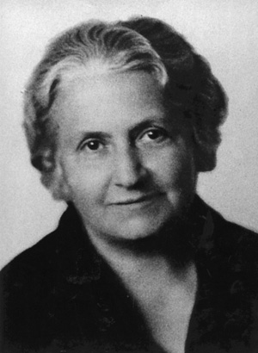
Picture Exhibit 2 Maria Montessori

Montessori schools are designed to make the best possible environment to facilitate the pupils’ desire to learn without restriction. As such, all learning materials have a designated place and are always within reach of the children. As a rule, there is only one of ach utensil in each class in order to promote sharing and cooperation amongst the children. Classes are not arranged in age groups in Montessori schools, but are mixed so that children of differing ages can learn from as well as support one another to enhance social competencies.

The fundamental guiding principles of the Montessori philosophy are:

- Independent work (Children be left to/encouraged to work independently without unnecessary interruption or intrusion)
- Well prepared environment (in order to be able to work independently, the learning environment must be prepared and offer children all the required tools for learning)

5.2.1. Principles of Montessori pedagogy

The following is a short description of the Montessori progressive education philosophy.

5.2.1.1. Independent work

Like the Dalton plan, the Montessori philosophy places great importance on independent working. That children have a free choice in their work is also a key pillar of this concept with the intended ambition of fostering independence amongst children. The child can determine with which tools he/she works, for how long and how often, with whom and for how long it works.

Conditions set out in the Montessori progressive education theory in order to enable independent working are:

- A Prepared environment
- Didactic materials
- Teachers who share Maria Montessori’s ideals
5.2.1.2. The Montessori teacher

The teacher’s role is to act as a helper. They support the children a long their own personal developmental pathway. One of the most critical responsibilities of the teacher is to prepare the materials and tools which the children may need to learn. The teacher should do their utmost to avoid interfering with a child’s work unnecessarily.

“Hands are the tools of human intelligence”
Maria Montessori

Something that differentiates the Montessori approach from other progressive education approaches is the learning use of learning materials. Maria Montessori developed such tools herself. The tools are closely related and have either direct or indirect error feedback systems. Common characteristics of Montessori learning materials are:

- Each tool represents one cognitive learning step an is also restricted to a singular level of difficulty
- All materials require the child to use their hands to play with concrete objects
- Through working with the materials the child should be not just cognitively stimulated but its sensory and psychological receptors should also be activated
- The prepared environment, the teacher and the materials form a three-point framework in which the child is able to safely design its own rules

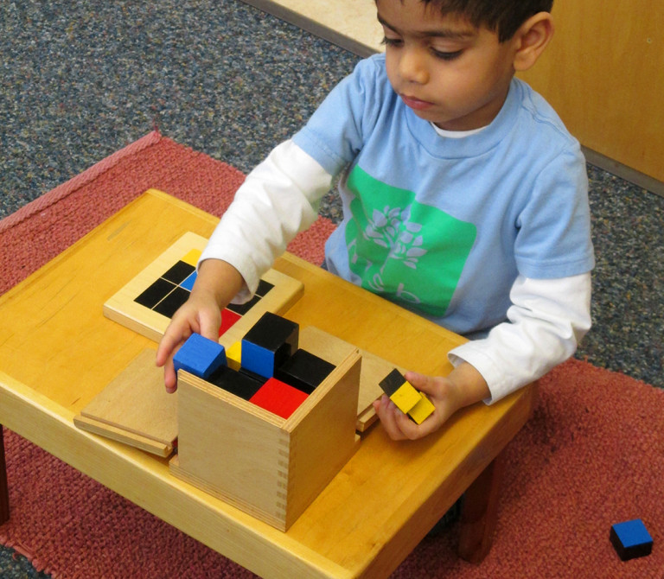
Picture Exhibit 3:Pupil is playing with Montessori materials

5.2.1.3. Prepared environment

“An adult‘s responsibility is so great, that they are compelled to investigate, with such scientific rigorousness, the needs of a child in order to prepare the appropriate environment”
Maria Montessori

Maria Montessori pioneered the prepared environment, a space in which a child can occupy themselves and focus on building their character.

Such an environment, according to Montessori, must:

- be relaxed and attuned to the child
- be orderly and easily understandable
- encourage activity

5.3. Jena Plan education theory

The Jena Plan philosophy was conceived in 1927 by the pedagogue Peter Petersen. The fundamental principle of this philosophy is that children should work together in order to learn from each other and train social competencies. There is no fixed school timetable and topics are taught over a period of several weeks at a time. The reasoning being, that this approach enables learners to assimilate knowledge more efficiently. Another underlying principle of the Jena Plan theory is that learning should be made as playful as possible and with a focus on learning through practical tasks.

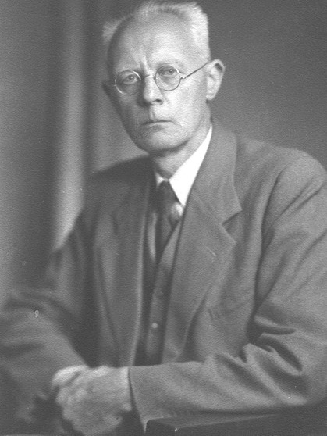

Picture Exhibit 4 Peter Petersen
The fundamental guiding principles of the Jena Plan philosophy are:

- Discussion (round-tables, debates, oral reports, idea sharing)
- Play (free play, learning games, gymnastic games)
- Work (core teaching, free work, course teaching)
- Celebration (morning circle, week closure, birthday parties and enrolment celebrations)

5.3.1. Concept of the Jena Plan School

Jena Plan schools take Peter Petersen’s concept as an initial base or attitude to education. Similar to Parkhurst’s Dalton Plan, there is no fixed ‘rule-book’ of what a Jena Plan school should like. The fundamental idea is to orientate such schools around school-related and social difficulties with emphasis on situational learning and situation development opportunities.

As such Jena Plan schools are continually in a state of continual development, always striving to find answer to the specific problems of the children, the teachers and parents at the specific location of the school.

Peter Petersen saw schools as ‘living spaces’ rather than places where lessons take place. The reason being that the later only preoccupies itself with the student whereas the Petersen’s philosophy sees the child as a whole person. Classrooms should become ‘cells of instruction’ and should be arrange to be a ‘school living room’ which provides the children with safety and, at the same time, numerous opportunities to broaden their horizons.

Petersen did not believe that an unstructured timetable, used with his permanently expanding and interdisciplinary subject combinations, would not provide children with a suitable perspective of the world. So, he designed rhythmic weekly assignments which attempt to structure the week in a logical fashion for children. The assignments also try to offer freedom at the same time as containing obligations.

The teacher should structure lessons in a way that enable children to independently find problems, work on and solve them whereby they are able to finish a chain of thought or task in peace and calmness.

5.3.2. Foundations of Jenaplan

As mention above, Jena Plan schools are based on the four educational principles of discussion, play, wok and celebration. A closer description of each follows below.

5.3.2.1. Discussion

According to Peter Petersen, talking with one another, communication, is the most important of the four pillars, when one considers it from a developmental psychologist’s standpoint; the way a person communicates can inspire children to be active. Therefore, all forms and forums of communication are important: roundtables, class discussions, group talks, reports, pronunciation, etc.

5.3.2.2. Play

Children should have ample opportunity to play independently. In the Jena Plan philosophy, playing is considered to be an entirely separate, but just as crucial, area of human development. It is seen as no less important as work, for example, for a child’s development.

5.3.2.3. Work

The Jena Plan theory differentiates between two parts of the working situation: group work and courses. During the group work part, children sit at tables in their ‘core tutor groups’. Children are allowed to choose where they sit and with whom they work. In these work parts, children work together on maths, language and nature and culture-related tasks. The work is often presented as “work contracts” and children are responsible for adhering to their contracts, with the help of the teacher.

5.3.2.4. Celebration

Celebration is something which should feature regularly in Jena Plan schools, be it to celebrate the start or end of the week or month, birthdays or achievements. Celebrations take place as a core tutor group, as a year group or as a whole school. According to Petersen, celebrating together is an activity which forms an integral part of building a living and working community.

5.3.3. Group configuration

The opportunity for a child to work individually should go hand in hand with the opportunity to work as part of group. As previously mentioned, a child’s group in a Jena Plan school is his or her tutor group which is a heterogeneous group of different ages. This grouping of children from across different year groups in one unit is intended to strengthen the sense of community within the school.
Peter Petersen’s suggested heterogeneous groupings were as follows:
- 5 years (young childrens’ group)
- 6 to 9 years of age
- 9 to twelve years of age
- 13 to 14 years of age
- 15 to sixteen years of age
6. School rhythm

In this section the rhythm of school life at the de La Tour School Seiersberg and that of Montessori and Jena Plan schools will be analysed and compared.

6.1. Start of the school day

Before discussing the weekly rhythm of the de la Tour School Seiersberg, it is intuitive to first ask the question: When should the school day start? This seemingly simple element, as an ever growing number of studies have shown, has wide-reaching implications for a child’s cognitive ability to learn.

Start of the school day: when is the best time to start for children’s learning and development?

6.1.1. A comparison of school start times in Europe

Across Europe there is no singular common start time to the school day. This variety across countries, and even within countries, can be traced back to historical, rather than pedagogical roots.

The huge discrepancy within Europe can be seen in Fig. 1 Below:
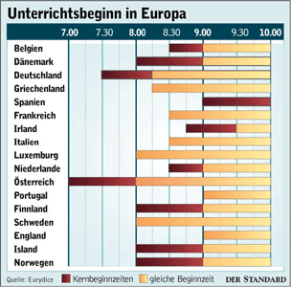

Picture Exhibit 5: Lesson start times in Europe

It can be seen in the comparison table (fig. 1) that Austrian mainstream schools have the earliest lesson start time of 7 a.m. whereas the majority of European countries have a start time of between 8 a.m. and 9 a.m..

6.1.2. Start of the school day: when is the best time to start for children’s learning and development?

“Which chronotype a person is depends on their genetic predisposition. A person is born as either a nocturnal ‘night owl’ or early rising ‘early bird’ and is either lucky or unlucky when it comes to the start of school.
In addition the genetic predisposition, a child’s age also plays a role: the sleep pattern of pubescent children generally shifts towards that of a ‘night owl’. So it’s mostly adolescents who lose out on sleep – they must get up early in the morning but are unable to fall asleep early enough at night to reach their required amount of sleep of eight to ten hours. The result is a ‘social jetlag’, the term given to the state of a teenager who is constantly tired and who simply drifts through life. The effects of this on not only academic achievement but also on health can be dramatic: it has been proven that chronic sleep deprivation can lead to growth disorders, obesity and depression.

Numerous studies have concluded that a later start to lessons would positively affect around 70 per cent of adolescents. It is an impressive figure should almost three quarters of young people be able to learn more and better and be healthier on top, were the school day to start later”
RENÖCKL, GEORG, Warum die Schule für viele zu früh beginnt

6.2. Montessori education
Montessori schools orientate themselves around the individual skills, abilities and talents of their pupils. Montessori methods are intended to strengthen a child’s desire to learn as well as to promote the ability to think and learn independently. Furthermore, Montessori schools follow a specific developmental and pedagogical concept, a learning environment with specially developed learning materials and a particular roll for teachers:

6.2.1. Sensitive phases
In the so-called ‘sensitive’ phases children are more susceptive to activities which develop and train specific skills such as verbal or motoric skills. With appropriate and timely stimulus children are able to concentrate more easily and learn formal and content-related topics better, faster and more permanently. The teacher must recognise and respond to these phases accordingly to promote the children’s learning.

6.2.2. Prepared environment
A prepared environment means that all learning materials and tools which support the children’s inherent desire to learn must be available and easily visible (at eye level) to all. Only one of each tool is made available in each class, the intended purpose of which being to promote social skills and cooperation amongst the children.

6.2.3. Role of the teacher
In line with Montessori tenet “help me to help myself”, teachers take on the role of a ‘helper’. They accompany the children a long their developmental pathway by explaining how the learning materials and tools can be used and by acting as a point of contact for the children. Teachers also ensure order in the process by acting when a child is unable to cope, becomes unmotivated or disturbs others.

6.2.4. Lessons according to Montessori
In Montessori schools classes are composed of children of mixed ages and abilities which are usually mentored by two teachers. Pupils can, if necessary, approach the teachers for help but can also ask for as well as offer help to fellow pupils and, by doing so, learn from one another. This process of give and take reinforces a strong sense of togetherness with the class.

6.2.4.1. Open work
During the open work phase children may decide for themselves which topic or subject they would like to work on. Every child can use the special Montessori learning materials and tools and work following their own rhythm. Consequently, the pupils are encouraged to learn and revise independently as well as working at their own pace. The idea is to allow children to optimise their own learning processes.
In the open work phase the emphasis is on learning through one’s own drive following the Montessori philosophy’s underlying belief that every child has an inherent desire to learn. At secondary level the amount of open work phases are reduced and replaced with long-term project work.

6.2.4.2. Interdisciplinary lessons

In Montessori schools interdisciplinary specialist subject lessons follow the free work phase, such as English or Mathematics. These lessons contain differentiated content: while some pupils learn addition, others work on subtraction. Tests are written and differentiated in accordance with the abilities of each child.

6.3. Jena Plan education
A Jena Plan-school orientates itself around four distinct characteristics:

6.3.1. Recurring weekly planning
Recurring weekly planning takes place in which each child is able learn both independently and socially. This encompasses the opportunity for children to improve their individual basic knowledge and skills in a proportionate manner (differentiated course system), in addition, pupils learn key competences such as teamwork, creativity and critical thinking through social experiences (group work, celebrations and discussions).
    - Mixed aged tutor groups

During certain phases throughout the day, children work together in tutor groups consisting of children of differing age groups. As a rule, children across three year groups are taught together in one tutor group. This promotes the development of natural learning processes where the advantage of social and interpersonal relationships can be harnessed (less pressure and fear; increased emotional stability, curiosity and joy).

    - Avoidance of performance culture
Jenaplan schools do not ascribe to grouping children into groups based on ability. The philosophy believes that doing so restricts and even prevents important learning processes and developments from taking place. Such a ‘performance-based culture’ is avoided in Jenascchools.

    - Parent-school community

Jenaplan schools are open to all parents and encourage parents to actively involve themselves in schools life. Parents are seen as important partners of the school.

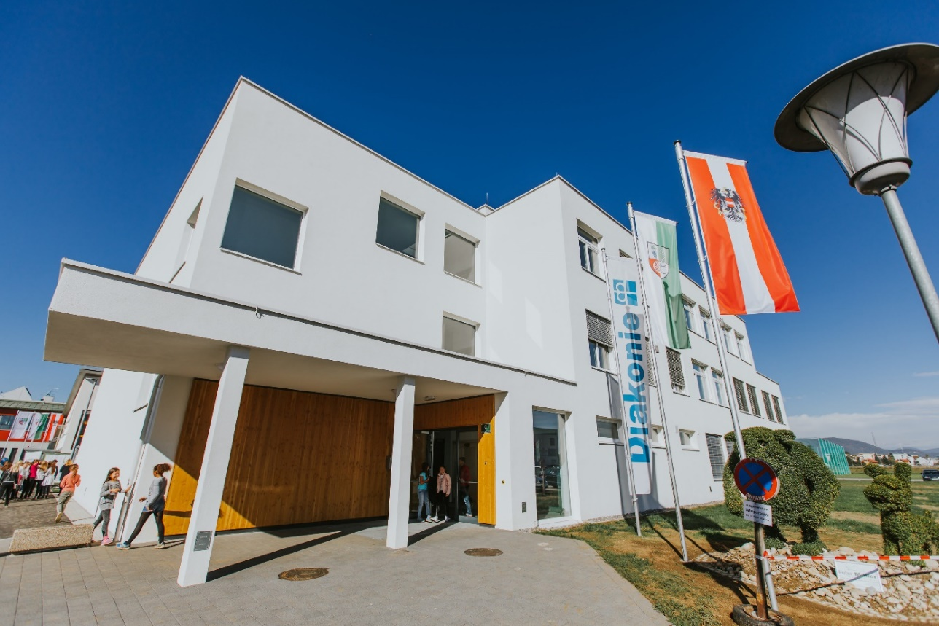
  - de La Tour School Seiersberg

Picture Exhibit 6: de La Tour School Seiersberg
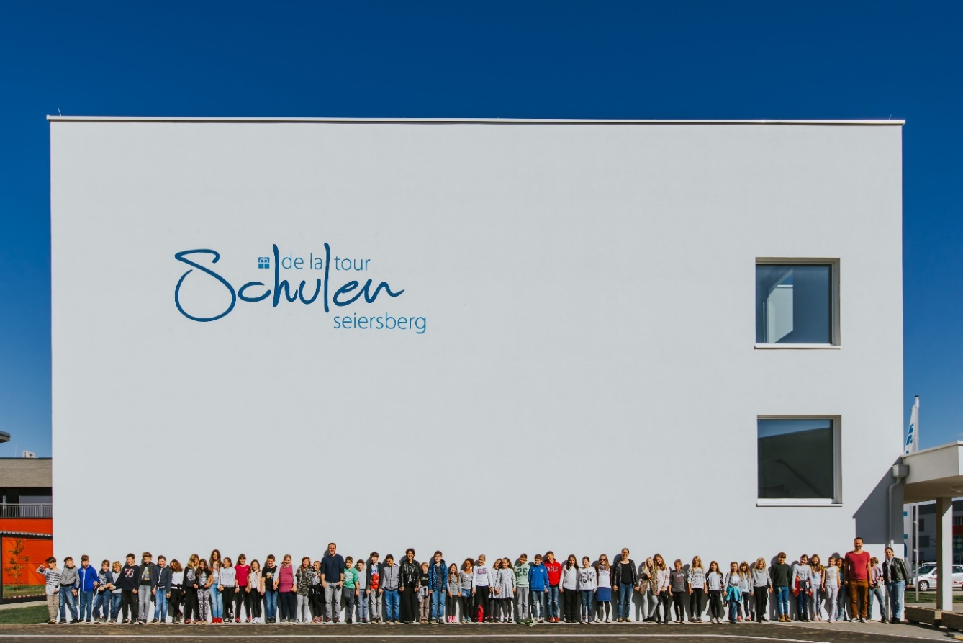
Picture Exhibit 7: de La Tour School Seiersberg
6.4.1.Early morning care (Morning café)

As discussed above, a later start is not only preferential, but much more advantages for a child’s cognitive development as well as their health. However, the reality is that society has not yet made the required shift in thinking that would allow everyone to realise such a school start time. In the past, it was commonplace in western society that the father of the family went to work and the mother stayed at home to care for the children and the household. In modern society, it has become the norm that both parents are in full time employment, and society’s relatively inflexible working times have a direct impact on the start of the day for many children.

As a result of these societal pressures, a school must adapt to fulfil the well documented cognitive benefits of a later school start as stated above, while accommodating the relatively inflexible daily timetable of the modern family. One concept which attempts to achieve this fine balance is early morning care.
At the de La Tour Schule Seiersberg, morning café begins at 7:30 a.m. and ends at 8:30 a.m.. During this time pupils, who for whatever reason must leave home earlier, have to opportunity to have breakfast together with fellow pupils at school or to simply relax and talk. This allows friendships to be fostered and social competencies to be developed through games and communication.

In addition, those children who predisposed towards being ‘early birds’ also have the chance to work on assignments and catch up on work they were unable to finish. The early morning care is supervised by two teachers who are available to support the children with anything they may need.

6.4.2. Start of the school day (Assembly)

The morning gathering of children and teachers has been a staple of the school day in many countries and educational systems for decades, it is however, not common place in Austrian schools.

This gathering in many traditional schools follows a common procedure of teachers dictating new information, administrative changes and teacher decided solutions to problems. There is little to no input from the children themselves and little room for discussion. There are, however, other ideas, on how this first and important part of the school day can organised in a way which shifts the focus away from the teachers and places it into the hands of the children themselves. Many of these different approaches to how a morning assembly can work stem from progressive teaching methods:
“[The morning school gathering is] one of the most important democratic structures and shows the difference to a normal mainstream school. Decisions are made through voting with simple majorities.” Strolz & Unger, die mündige Schule

6.4.2.1. How does it work at the de La Tour School Seiersberg?

This phase is called ‘assembly’ at the de La Tour School Seiersberg and takes place between 8:30 a.m. and 8:45 a.m.. Assembly means a gathering. It is a time when the school and/or year group comes together as a whole to celebrate birthdays, sing songs, to provide food for thought and to reflect.

Moreover, assembly acts as a forum for organisational and important matters to be discussed and, at times, voted on to reach decisions which affect the school or school day.

6.4.3. Open work phase (Dalton phase)

Learning is very much an individual process. The pace at which one learns, the way in which one processes information, the methods which one employs and the most effective stimuli for learning varies from person to person. Therefore, to try and employ a universal, restricted and inflexible lesson structure can counterproductive to the learning process. Traditional frontal, teacher-led learning relies on the premise that everyone learns in a homogenised way; namely, at the same pace, in the same way and through the same methods.

There are various chains of thought within progressive teaching methods on how open learning theory can be employed to create open classrooms, which accommodate and promote the individual learning needs of children.

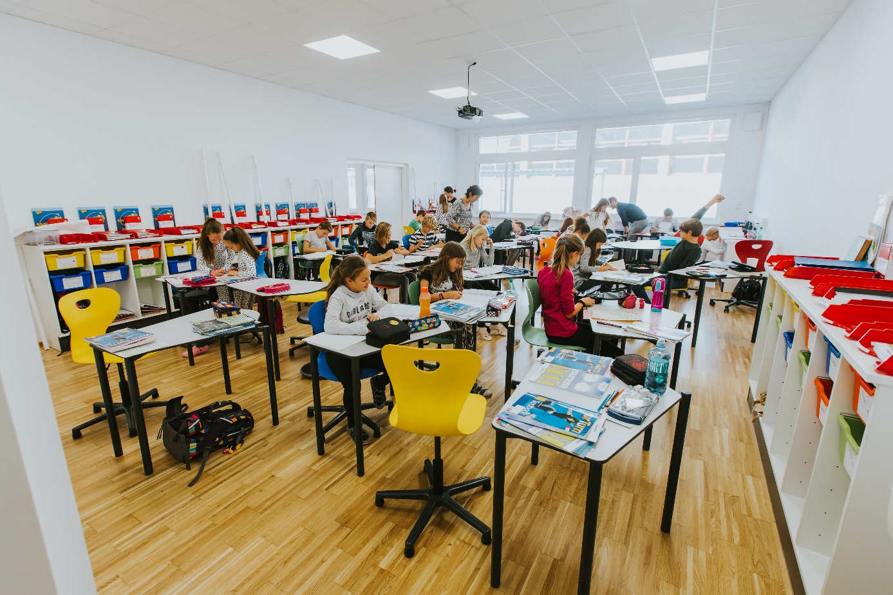
Picture Exhibit 8: Open work phase (Dalton phase)

6.4.3.1. How open learning theory is put into practice at the de La Tour School Seiersberg

Following assembly, the children go into at 8:45 a.m. the Dalton phase (open work phase), the homogenous age group classes are broken up and classrooms become so-called subject rooms (or ‘learn Bureaus’). There are subject rooms for each of the main subjects: English, German Maths and Spanish as well as a ‘Flexi room’.
Each room contacts the subject-related learning materials which are made available to all. Pupils of all ages spend time together in the different subject rooms. The Dalton phase is a continuous and uninterrupted open work phase which lasts for to full hours.

During the Dalton phase, each pupil may decide which subject they he/she would like to learn and through which social form, be it individual, partner or group work as well as with the support of which teacher. In this case, students may as for the support of a subject specialist teacher or from a teacher with which they feel they have a closer relationship.

The children orientate their preferred learning methods around the prescribed curriculum included in their plans. This freedom of choice promotes the children’s independence and their ability to work autonomously. Thus, children can take their individual learning pathway and at their own pace enabling them to steer their learning by preference or necessity. For example, should a pupil’s strength lie in maths, they can use the time saved in maths to invest in another subject where they experience more difficulties like, for example, German.

The Dalton phase enables a wide range of cooperative learning processes to take place, through which promote not only academic learning, but also, and critically, social and practical competencies.

6.4.3.2. Learn plans (Assignments)

Every child receives a learn plan, called an Assignment, for each of the main subjects (English, German, Maths and Spanish) and for each learn period. The duration of each learn period can vary but lasts on average between one to two weeks. The assignments consist of various tasks which cover the required knowledge which should be obtained by each pupil.

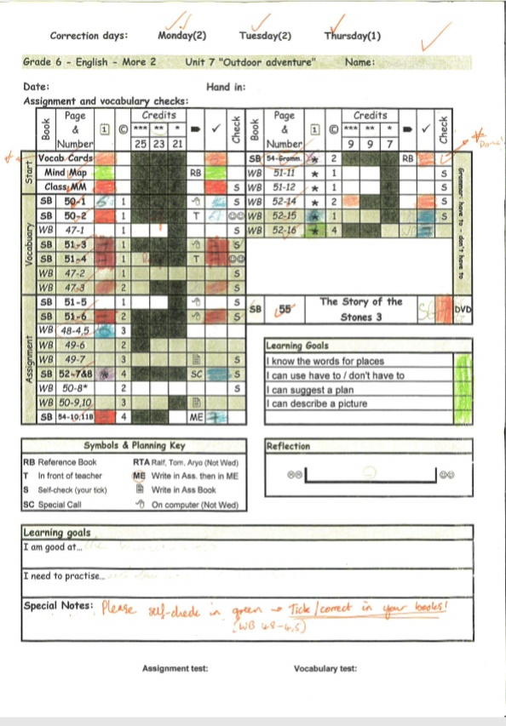
Picture Exhibit 9: English Assignment

During each assignment, pupils have a number of so-called hand-in days on which they must submit the work which they have done individually to the subject teachers. This allows the teachers to check the progress of each individual child, resolve any misunderstandings and offer support where necessary so that the child may continue to work independently on the assignment, having received appropriate feedback from the teacher.

The assignment also take into account the individual abilities of the pupils and contains a three tier differentiation system. This system enables each child to choose which tasks they would like to tackle and at their own pace in order to advance their knowledge.

6.4.4. Recovery phase

The distribution of lessons into short lessons of 50 minutes with an average of 10 minutes’ break in between each lesson follows a long tradition which can be traced back to a decree by the Prussian minister of culture, August von Trott zu Solz, in 1911 for grammar schools.
Zentralblatt für die gesamte Unterrichtsverwaltung in Preußen – 1911.

This structure of very short breaks has historical roots and has not been adapted to coincide with modern thinking and research on cognitive function.

6.4.4.1. How the recovery phase is employed at the de la Tour School Seiersberg.

Owing to the blocked Dalton Phase, it is possible to include an extended recovery phase in the morning, the so-called ‘big break’ which lasts for 45 minutes, from 10:45 a.m.to 11:30 a.m..

Excluding the ‘big break’ in the morning and the lunch break, breaks last between five and ten minutes. This time gives the children the opportunity to move around in the fresh air, play group games, communicate with each other or simply relax.

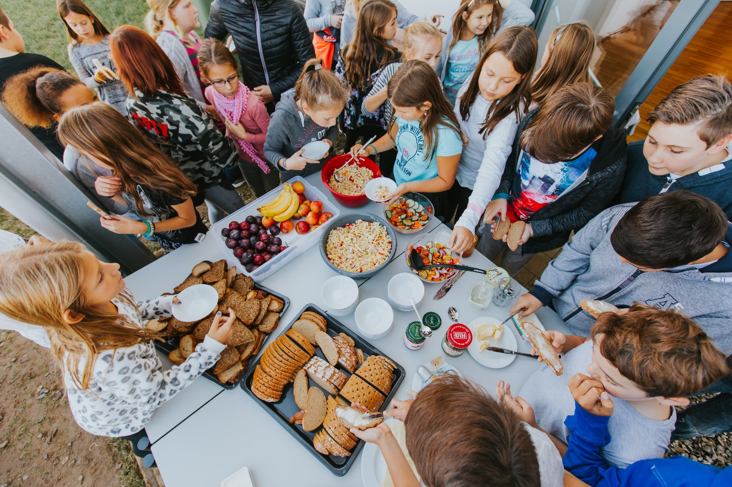
Picture Exhibit 10: Break time (Recovery phase)

Between the Special Calls and Subject lessons (described in below) there is are to short breaks of between five and ten minutes to refresh their minds, go to the toilet and to communicate with each other.

Following the subject lesson there is a further extended break of one hour for lunch from 2 p.m. to 3 p.m. before afternoon activities begin.

6.4.5. Instruction/input phase (Special Call)

The special call is time where each class comes back together into their tutor group (pupils of the same age and year group) to receive input to new topics from the teachers. Furthermore, this provides an opportunity for the children to asks questions and resolve problems they may have been unable to solve while working independently.

This targeted input from the teachers enables pupils to go into the Dalton phase equipped with the tools and materials they need to work autonomously on their assignments. It is also a time to revise topics which have already been covered, thereby refreshing and cementing knowledge.

Time to come to together as a class to introduce new topics within each of the main school subjects as well as provide the opportunity to review and revise topics which have already been covered.

6.4.6. Secondary subject phase (Subject Conference)

The subject conference takes place every day between 1:00 p.m. and 2:00 p.m. and is a phase where secondary subjects (Art, Biology, Geography, History, etc.) are taught in a blocked form over a period several weeks.

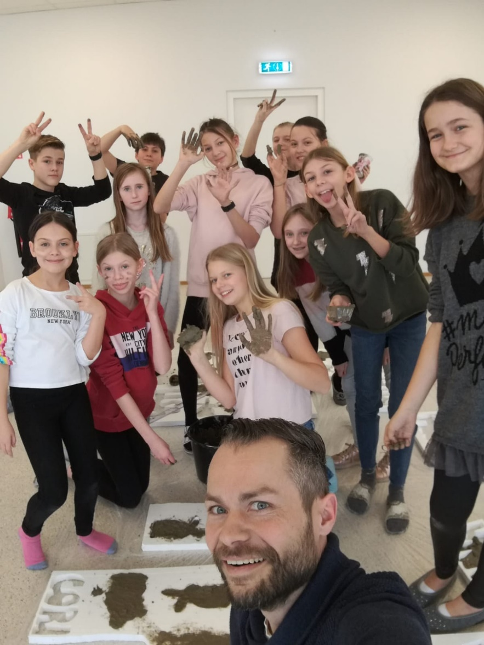
Picture Exhibit 11: Easter project (Subject Conference)

This periodic system allows more the pupils a concentrated focus on each particular subject where an intensive learning process can take place. As well as more academic subjects, children can also focus on their creative talents in the Music, Creative Design and Design Technology subject conferences.

7. Structure of the Academic Year

In mainstream schools in Austria, the school year is structured around semesters with half-term holidays half way through each semester as laid out by the Austrian ‘Schulgesetz’ (school law). This structure has some, perhaps surprising, origins. The so-called ‘Energieferien’ (energy holidays) were introduced in 1973 during a time of energy crisis. The reason was to save heating costs for schools. Since the introduction, mainstream schools have continued to follow this rhythm.
Robert Kratky, Semesterferien: Warum die Regelung sinnvoll ist

7.1. Structure of the academic year at the de La Tour School Seiersberg

The school year is organised into trimesters at the de La Tour Schule Seiersberg: an autumn trimester, a winter trimester and a spring trimester. Each trimester, in contrast to mainstream schools, does not feature any half-term breaks. Instead the Christmas and Easter Holidays are longer. The educational reasoning behind this is, firstly, to avoid interrupting the learning process at a critical point: in the middle of the trimester when the pupils have found the learning rhythm and their learning is at its most efficient. Secondly, the extended holidays between trimesters allow a prolonged period of rest and recovery for the children so that they may start the next trimester fully refreshed and motivated to learn.

Each trimester begins with a week of social activities designed to bring the children together and further social competencies as well as relationships between pupils and teachers. Only after this week does school work begin.

Each Trimester ends with a week of tests. This is an opportunity for the children as well as the teachers to see what they have learned and to reflect on the achievements of the trimester.

8. Summary and comparisons

 | Jena Plan | Montessori | de La Tour School Seiersberg
Perception of child | Humanistic, realistic view of individual as part of a community. Developing independence is fundamental. | Biological view of child. Treated as an individual. Catholic educational ethics. Developing independence is fundamental. | Holistic view of child with individual and age-specific needs. Developing independence is fundamental.
Group configuration | Core groups of mixed ages. | Partly employs mixed age groups. | Tutor groups organised according to age. Partly mixed aged classes (in the Dalton phase).
Classroom | „School living room“. Group room used as a space to work and to ‘live‘ | Organised around lesson activates – Montessori didactic materials and tools. | Subject rooms are used by different mixed-age groups simultaneously during the Dalton Phase. Children are taught in age homogenous classes for Special Call and Subject Conference.
Syllabus | Flexible content, basic teaching plan | Structured strongly around the Montessori developed content. | The goals of the syllabus are fixed but the way in which they are achieved is flexible - according to the decisions made by the pupils.
Teaching approach | Emphasis on learning through discovery – world orientation as a subject. ‘Natural learning‘. Activities arond iscussion, play, work and celebrate. | Independent working at the core, often working individually – linked t the didactic Montessori materials. | Heart of lessons is the open Dalton phase with independent working on assignments. A mix of frontal input phases and pupil-led sessions accompany the Dalton Phase.
Learning content and methods | Tasks built around current events, developments and content. Using the world around as learning tool. | Strong presence of classical content focusing heavily on the didactic materials. Choice offered within tasks. | Children are responsible for planning and fulfilling the tasks and assignments. Also responsible for how they work to fulfil the objectives.
Seating arrangement | Free, flexibal and functional. | Free and flexible but influenced by the emphasis on individual work. | Free, open and flexible seating with the condition of productive working.
Teacher's role | Teacher is learning companion to the children. | Ideally, teacher steps back entirely as the child learns independently from the specially designed materials. | The role of the teacher develops from instructor at the start of the assignment to moderator and coach during the assignment.
School type | Idea that the school is one single community is stressed. Open structures and democratic orientation. | Strongly structured around Montessori’s idea of a school rather than adjusting to accommodate main stream school system. | Focus on the school as one social unit rather than individual classes and year groups. Little orientation around mainstream school types/structures.

8.1. Perception of the child

At the de La Tour School, with its Dalton Plan philosophy, each child is taken and treated as an individual with their own specific needs. This can be seen, for example, in the differentiated tasks, and difficulty thereof, contained within the assignment. Value is placed on empowering every pupil, regardless of academic ability, to achieve their own individual goals.

Each child is recognised and accepted as being ‘imperfect’ – as having strengths and weaknesses. The teacher’s role is to encourage and support pupils to take advantage of their individual strengths to work on their weaknesses. A key element of this is allowing failure with the goal of analysing what didn’t work, together with the child, in order to learn from the experience going forward following the motto:

“If at first you don’t succeed, try, try, try again”
William Edward Hickson (1843)

However, it is important that one learns from one’s mistakes, thus avoiding repetition of that mistake. At the de La Tour School Seiersberg, time is dedicated to reflecting on one’s mistakes and correcting them in order to avoid repetition of the same mistake in future.

It is also a crucial element and stepping stone on the path to independence that children learn to cope with problems and situations on their own or as a group without unnecessary interruption from the teachers. Thus, teachers at the de La Tour School only intervene proportionately to provide guidance when the child has tried, but has been unable to work towards a resolution independently.

With this in mind, teachers strive to support the children and maintain their joy of learning through careful judgement of when to step in. The ‘right time’ varies from child to child depending on numerous factors such as age and psychological development. For this very reason, teachers at the de La Tour School perceive each child as an individual. This carefully timed and proportionate intervention is the ‘immense sensitivity’ which Helen Parkhurst wrote about and which was discussed above.

The approach taken at the de La Tour School Seiersberg, in terms of how the children are perceived, agrees with the Montessori approach that each child is seen as an individual with their own needs. The ultimate goal being that the child learns to become independent.

Furthermore, the perception of the child at the de La Tour School parallels that of the Jena Plan in that, not only is the individual is taken into consideration, but also each individual’s place in the group and community of the school.

8.2. Group Configuration

Fundamentally, children are organised into tutor groups with fellow pupils of the same school year. However, these classes are broken up during the Dalton Phase as children from all classes and year groups mix in the different subject rooms. In addition, tutor groups are often mixed with other pupils from other tutor groups of the same year group during input phases and so have the opportunity to work and interact with others from different classes.

This approach differs from that of the Jena Plan as Jena Plan tutor groups contain a mix of children from across a number of different year groups. This difference is also seen when comparing the de La Tour method with the Montessori approach.

That said, there are elements of age group cross working at the de La Tour School through the supporting guides who support both younger and older students to complete their assignments.

8.3. Classroom

The next point of comparison between the de La Tour School Seiersberg and other progressive educational approaches. Subject rooms or ‘learn bureaus’ form an integral part of the learning experience at the school. Each room contains the necessary subject-related materials and learning tools which can be used by the pupils to reach their assignment goals.

The classrooms contain tables and chairs of varying sizes to reflect the physical needs of the various children from different age groups. The tables and chairs can be moved around by the children themselves to reflect their preferred working style: individual, partner or group work.

The subject rooms are also the ‘home rooms’ of the subject teachers. For example, a maths teacher resides mostly in one of the maths subject rooms. So, should a child have a maths-related questions and wish to talk to a maths teacher, they know exactly where to go.

Between each subject room and the next there is also a ‘working room’ which contains an open working environment. Children can use these areas to work communicatively as a group whilst not disturbing those who have chosen to work individually in the class.

There is a noticeable difference between the de La Tour’s function for classrooms and the Montessori use of classrooms. Montessori differs in that children usually remain and work in the same room. The Montessori approach stipulates that all of the specially designed learn materials and tools must be made readily available and within reach of the children.

The Jena Plan idea of the classroom is similar to Montessori’s as a classroom is treated as a living room learning environment which is where each class spends its time.

Therefore, despite similarities elsewhere, the de La Tour School, Montessori and Jena Plan approaches differ when it comes to the use of classrooms.

8.4. Syllabus

When it comes to the Syllabus, the de La Tour School Seiersberg follows the national curriculum goals set by the Austrian Ministry of Education. However, as it is a charter school it has flexibility in how the curriculum is taught. Thus, the school combines open working phases (Dalton phase) with input phases in tutor group settings.

Jenaplan schools as well as Montessori schools follow their own individually developed syllabi. The Jena Plan syllabus is less defined and focuses on practical learning. The Montessori syllabus is heavily influenced by and integrated with the specially developed learning tools.

In this instance the de La Tour School approach to the syllabus takes a middle road between the mainstream curriculum of the state and the very different ones of other progressive education theories.

8.5. Teaching Approach

Open work phases with independent learning is at the heart of the teaching approach at the de La Tour School. The Dalton phase forms the core part of this independent learning and is supported with input lessons (Special Calls) which equip the children with the necessary tools they need to start their independent work, for example an introduction of the next topic. This is a concept which is has a lot of similarities with Montessori teaching concepts as, here too, independent working is the key focus. This is however, not surprising, considering that Helen Parkhurst studied under and worked closely with Maria Montessori.

“Help me to do it by myself”
Maria Montessori

The Jenaplan approach distinguishes itself here the other two as it places ‘world-discovery’ and learning through playing and celebration at the heart of its concept.

8.6. Learning Content and Methods

This is a field where there are notable differences between all three progressive education methods.

The de La Tour School, following the Austrian national curriculum, sets clear goals per assignment. However, in contrast to mainstream schools, his relative freedom in how these goals are achieved. Thus, children are offered a variety of ways how they can reach the goals of each assignment including books, audio and visual and materials, computer based work and presentations. Furthermore, some subjects have begun to integrate more, for example, English, German and Spanish in order to create cross subject and interlinked tasks and assignments.

The Montessori learning content and methodology is heavily based on the specially designed learning materials and tools. Content offerings and methods of learning and working are all centred around, and sometimes limited by, these materials. The content also tends to be dominated by classic learning content, as this is what the materials where designed around at the time of conception and have changed little since then.

The Jena Plan, on the other hand, concentrates heavily on daily influences and current events, drawing on ‘life experiences’ as a tool for practical learning. It follows a basic but flexible syllabus and content plan and can, therefore, react to life events and turn them into learning experiences.

8.7. Seating Arrangement

Seating arrangement is an area where cross overs can be clearly seen between the three methodologies.

The de La Tour School employs a free, open and flexible seating arrangements where there are no fixed places for pupils. Children may choose where to sit, and it can be a different place every day. There are, however, certain conditions attached to this freedom which reflect the Dalton plan’s philosophy of freedom with responsibility. Being able to work in that seating position without disturbing others would be one such condition.

If this condition cannot be fulfilled by the child, they lose the freedom to decide where they can sit. That is until such time they are able to prove that they are ready to carry the responsibility again.

Generally, both the Jena Plan philosophy and Montessori philosophy align with the Dalton philosophy followed by the de La Tour School. The Montessori philosophy deviates slightly as it has more of a focus towards individual working and, thus, individual seating.

8.8. Teacher’s Role

In this category, the three approaches show similarities but, at the same time, differing stand points.

At the de La tour School, teachers have a cyclically transitional role. At the beginning of each assignment, the teacher has the role on instructor. New topics and content are introduced to equip the children with the necessary basic skills and knowledge to then be able to work independently. Once the instruction phase is over the teacher moves to a coach role – a person who accompanies the children on their learning pathways.

The Jena Plan approach sees teacher’s as learning companions through all parts of the learning phase.

The Montessori Philosophy encourages teachers to actively remove themselves from the learning process in order to avoid impeding the interactions of the child with the specifically designed learning materials.

8.9. School Type

Again, there is a very close connection between all three methodologies here. Each promote a holistic vision of school as a single unit – a single community across all classes and year groups. Barriers are broken down to enable interaction between different year groups in work and social contexts which encourages communication and understanding.

9. Conclusion

The paper set out to analyse and compare three progressive education approaches and to show that, despite differences among them, inspiration and elements can be drawn from each of them to benefit the learning process and experience of children in schools and, perhaps most importantly, prepare them for all the challenges and inherent unpredictable of life.

As described during this paper, each approach to education has its own methods, focal points and ideas. However, using the example of the de La Tour School Seiersberg, this essay has worked to highlight there is no single, perfect approach which should be applied in and adhered to in a strict, religious and militaristic fashion.

On the contrary, all of these approaches contain valid and positive ideas which can be combined with ideas from other approaches to create a learning environment which truly benefits the children it is intended to serve. As described in section four, all progressive education philosophies strive for the same goal: to allow the child’s innate desire to learn. In pursuit of this goal, many of the different philosophies share unifying characteristics to achieve that end.

Despite being heavily influenced by Dalton Plan Theory, the de La Tour School Seiersberg shows one possible practical embodiment of different elements and practices from a number of progressive education theories. These are harmoniously combined with the goal of putting the child at the heart of its educational endeavours. This is not to say that the school is a perfect example of a perfect system, rather it is just one example of how education can be refocused onto the needs off the learners, rather than those of the educators.

As pointed out by Helen Parkhurst, among others, it is vital to continuously innovate, not to sit on one’s laurels and to fall into the trap of habit when it comes to educating our children. The world in which we live is ever-changing and so are the challenges faces humankind. How we prepare our children must reflect that prepare them for the various challenges and eventualities as well as opportunities which they may encounter in their future lives.

It is therefore, critical that teachers and educators themselves are not afraid to try new ideas in pursuit of these educational goals. As children should be allowed to try and fail, so should their teachers, as it is from such experiences that all involve learn the most.

This paper will finish with a quote and an idea which it has already touched on from the British educationalist William Edward Hickson:

If at first you don’t succeed, try, try, try again”
William Edward Hickson (1843)

10. Bibliography

10.1. Literature

- Helen Parkhurst, aus dem unveröffentlichten Typoskript von Janssen, C. J., Der Daltonunterricht und seine Stelle innerhalb reformpädagogischer Auffassungen. unveröffentlichtes Typoskript, S. 12
- Janssen, C. J., Der Daltonunterricht und seine Stelle innerhalb reformpädagogischer Auffassungen. unveröffentlichtes Typoskript, Seite 12
- Janssen, C. J., Der Daltonunterricht und seine Stelle innerhalb reformpädagogischer Auffassungen. unveröffentlichtes Typoskript, Seite 13
- Maria Montessori, Vergleiche des Erziehungskonzept zur Selbstbestimmung
- Vgl. Popp, Susanne, Der Daltonplan in Theorie und Praxis. S. 93
- Zentralblatt für die gesamte Unterrichtsverwaltung in Preußen – 1911. Seite 528 (http://goobiweb.bbf.dipf.de/viewer/image/ZDB985843438_0053/529/#topDocAnchor, S.528f)
- Robert Kratky, Semesterferien: Warum die Regelung sinnvoll ist, 30. Jänner 2015
https://oe3.orf.at/stories/2692099/
- Popp, Susanne, Der Daltonplan. in Theorie und Praxis. Ein aktuelles reformpädagogisches Modell zur Förderung selbständigen Lernens in der Sekundarstufe, Bad Heilbrunn 1995
- RENÖCKL, GEORG, Warum die Schule für viele zu früh beginnt, 15. September 2016 - derstandard.at/2000044373567/Muede-Kinder-Beginnt-die-Schule-zu-frueh
https://derstandard.at/2000044373567/Muede-Kinder-Beginnt-die-Schule-zu-frueh.
- Strolz & Unger, die mündige Schule, 2015

10.2. Image reference

Picture Exhibit 1: Helen Parkhurst: https://daltoninternational.org/helen-parkhurst/
Picture Exhibit 2 Maria Montessori: http://www.montessori-inning.de/ueber-uns/maria-montessori/
Picture Exhibit 3:Pupil is playing with Montessori materials https://msb.org/wp-content/uploads/IMG_2464-768x670.jpg

Picture Exhibit 4 Peter Petersen: https://www.br.de/themen/wissen/jenaplan-paedagogik-100.html
Picture Exhibit 5: Lesson start times in Europe: (https://derstandard.at/1209305/Unterrichtsbeginn-in-Europa)

Picture Exhibit 6: de La Tour School Seiersberg: https://www.delatour-schulen.at/sites/default/files/2018-01/dlt-1061.jpg

Picture Exhibit 7: de La Tour School Seiersberg: https://www.delatour-schulen.at/sites/default/files/2018-01/dlt-1062.jpg

Picture Exhibit 8: Open work phase (Dalton phase): https://www.delatour-schulen.at/sites/default/files/2018-01/dlt-1024.jpg
Picture Exhibit 9: English Assignment

Picture Exhibit 10 :Break time (Recovery phase)
https://www.delatour-schulen.at/sites/default/files/2018-01/dlt-1063_0.jpg
Picture Exhibit 11 : Easter project (Subject Conference)

